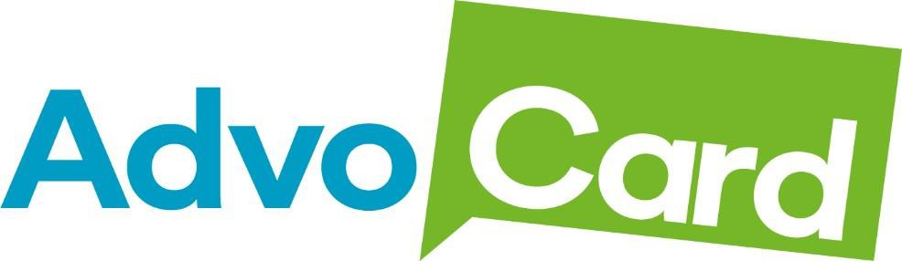



Annual Report 2023/24



Our Year in Review

Achievements and Challenges

1594 people used our service

2474 new referrals.

# Achievements – in addition to beginning delivery of our new contract with City of Edinburgh Council, this year was a period of consolidation and potential growth

1. **We Moved to Duncan Place**  
   This year, we settled into our new home at Duncan Place! The move has given us more space to work, collaborate, and grow. It’s a fresh, welcoming base for our team, volunteers, and the people we support, and it sets us up perfectly for the future.
2. **Funding Boost for Outreach Services**  
   Thanks to additional funding from the Community Mental Health Welfare Fund, we’ve been able to grow our Outreach services. With this support, we’ve reached more people, offered more help, and made an even bigger impact in our community. It’s been a game-changer for our work.
3. **New Training Opportunities**  
   We teamed up with the Skills Network to bring training opportunities to all our staff and volunteers. This partnership means everyone has access to resources and learning that help them grow and do their jobs even better. It’s been a great step forward for us as a team.

e

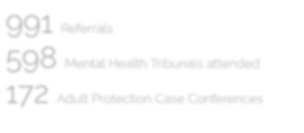

1075 Referrals

609 Mental Health Tribunals attended

229 Adult Protection Case Conferences

Individual Mental

Health Advocacy

**Adapting to Our New Contract and Meeting Growing Demand**

This year marked the beginning of our new contract with the City of Edinburgh Council, which commenced in July. The updated contract brought with it revised monitoring and reporting requirements, prompting us to make adjustments to how we deliver our services. While these changes required some adaptation, they also gave us an opportunity to refine and strengthen our processes to better meet the needs of those we support.

To help navigate these changes and provide additional support to our team, we created a new Senior Advocacy Worker post. This role has been instrumental in introducing a triage system for managing referrals. By taking on the initial contact, the Senior Worker ensures that referrals are assessed and prioritized effectively, allowing the wider team to focus on providing direct advocacy support.

This new structure has been especially valuable in helping our Mental Health Team manage the growing demand for statutory advocacy. This year, the team received an incredible 1,075 referrals offering essential support during Mental Health Tribunals, Adult Support and Protection Case Conferences (ASPCC), guardianship hearings, hospital admissions, and care planning meetings. The increase in numbers highlights both the increasing need for our services and the critical role our team plays in ensuring people receive the support they are entitled to during some of the most challenging times in their lives.

This year’s developments have strengthened our ability to provide high-quality advocacy, even in the face of rising demand. The changes we’ve implemented under the new contract have equipped us to meet challenges head-on while continuing to prioritise the needs and rights of those who use our service. It’s been a year of growth and adaptation, and we’re proud of the difference we’ve been able to make.

***“…….. helped me prepare for my tribunal and gave me the confidence to express how I really felt. Without them, I don’t think I would’ve been able to get through it”***

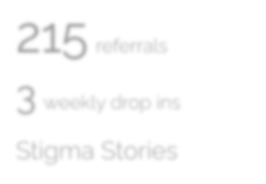

Problematic

Substance Use

306 referrals

3 weekly drop ins

**Adapting to Change and Continuing to Support Our Community**

With the new contract came changes to how we’re funded, which led to adjustments in how we manage referrals. All referrals are now handled by a part-time worker, with support from our Team Leader, Operations Manager, and four Volunteer Advocacy Workers. Despite reduced hours, the team has done an incredible job, supporting 117 individuals and handling 212 new referrals.

The issues we’ve helped with this year have included access to treatment, support services, and housing. However, we’ve also noticed an increase in referrals involving multiple, complex issues. These cases often require us to work closely with other organisations to make sure people get the comprehensive support they need. We’ve seen a big increase in referrals for housing issues and people experiencing homelessness. It’s clear there’s a growing need for help in this area, and we’ve worked hard to provide the right support.

This year’s work has been all about meeting people where they are, offering support that makes a real difference, and contributing to wider efforts to bring about positive change. We’ve run regular drop-in sessions at the Harm Reduction Clinic and the Central Prescribing Clinic, giving people easy access to advice and support when they need it most

We’re also continuing to be actively involved in wider advocacy efforts. AdvoCard plays an important role in the Edinburgh Alcohol and Drug Partnership (EADP) meetings focused on Medication-Assisted Treatment (MAT) delivery. Additionally, we’re contributing to the National Collaborative, which is developing a Human Rights-Based Approach (HRBA) to support people using substances.

Our involvement with the National Collaborative highlights our commitment to human rights-based advocacy. By promoting this approach and challenging discriminatory practices, we’re helping to reduce the stigma often associated with substance use. This work is essential in creating a more inclusive and supportive community—one where everyone is treated with respect and has equal access to services.

2 Training Courses

18 Volunteers

299 referrals



Volunteer Delivered Advocacy

19 volunteers

AdvoCard’s volunteer service is where it all began, and it remains a huge part of what makes us successful today. Volunteers play an essential role in delivering our advocacy services while giving people with lived experience the chance to take part in meaningful activities.

This year, we ran two volunteer training courses, giving participants the opportunity to build valuable skills, gain experience, and grow in confidence as advocacy workers. These courses not only strengthened the skills of our volunteers but also benefited the wider community by enabling us to offer a more inclusive, empathetic, and supportive advocacy service led by people who truly understand the challenges faced by the people who use our service.

With more trained volunteers on board, we’ve been able to offer better and broader support across the community. This year, the team handled 399 referrals, supporting individuals with issues like housing, accessing treatment, making complaints, and more.

For many of our volunteers, their time with AdvoCard is a stepping stone to other opportunities like further education or employment. This year, we partnered with the Skills Network to offer accredited training in social care qualifications. These courses give our volunteers recognised credentials and experience that can help them pursue careers in social services, advocacy, and related fields.

Our volunteer service isn’t just about providing support—it’s about creating opportunities, building confidence, and making a difference for individuals and the community as a whole. It’s a vital part of who we are, and we’re proud of what our volunteers achieve every day.

1hours delivered

Volunteer Service

.

.



Outreach

177 referrals

5 weekly drop ins

Thanks to ongoing funding from the Community Mental Health Welfare Fund, we were able to recruit a new part- time advocacy worker for our outreach team which helped us to increase our capacity and provide more drop ins and community engagement opportunities.

The team remained focused on building a strong community presence in the North East Locality of Edinburgh this year and continued to build on collaboration with local organisations and community groups creating a network of support that enhanced the accessibility of our advocacy services.

By bringing our services directly into the community, we reduced the barriers to access, such as transportation, stigma, or lack of awareness that many people faced. This ensured that more people benefited from advocacy by attending drop ins, talking to our advocacy workers at local organisations or by having an advocacy worker visit them at home.

In addition to the 117 people who directly accessed support from our advocacy team, we also saw a 40% increase in referrals from the Craigmillar/Niddrie area as individuals and organisations became aware of our service in that area. As we continue to expand our outreach work, we remain committed to fostering strong, collaborative relationships that will amplify the positive impact of our advocacy work and enable more people to access our services.

***“……. helped me understand my rights and explained everything in a way that made sense.***

***It made me feel more confident and less scared during a really difficult time”***

Welfare Reform – 194 individuals supported

**Supporting People Through Scotland’s Changing Welfare System**

Scotland’s social security system has been going through some big changes, with certain benefits now being managed by the Scottish Government instead of the UK Government. While these changes aim to improve the system, they’ve had a significant impact on vulnerable groups—especially those with mental health issues or who are affected by substance use.

These groups often face extra hurdles when trying to access benefits, such as stigma, confusion about the system, and difficulties gathering the right evidence to support their claims. This is where our Welfare Reform advocacy service steps in.

Our service is designed to tackle these challenges head-on, offering support tailored to the specific needs of the people we work with. We help them explain how their conditions affect their daily lives, ensure their voices are heard during assessments, and advocate on their behalf to secure the benefits they need to live with dignity.

Over the past year, our Welfare Reform worker has received 194 referrals. The most common issues he’s helped with include the transition from Personal Independence Payment (PIP) to Adult Disability Payment (ADP) and navigating the complexities of Universal Credit claims.

***“I just want to express my gratitude towards your employee Alistair in the way***

***he handled my ADP application. He gave me the upmost support necessary***

***to enable me to complete such a daunting and long process.”***

Individual Advocacy at HMP Edinburgh – 298 referrals

**AdvoCard’s Prison Advocacy Service: Supporting Inmates Through Change**

Over the past year, our service received 472 referrals from 298 prisoners, helping them with a wide range of issues, particularly financial matters and accessing essential services such as prisoner programs.

While efforts have been made to modernise and improve aspects of the SPS, prisons continue to face issues such as overcrowding, rising mental health crises among inmates, and limited access to necessary reform programmes. In this environment, AdvoCard’s advocacy service has become more crucial than ever. From navigating internal complaints procedures and parole board hearings to supporting individuals struggling with the practical difficulties of imprisonment, our team remains dedicated to helping prisoners access the support they need.



Looking ahead, we want to keep growing, reaching more people, and making our services

as accessible and effective as possible. None of this would be possible without the amazing

efforts of our staff and volunteers, who go above and beyond every day. A huge thank you

to our board for their guidance, our funders for believing in what we do, and our members for

their trust and support. Together, we’re making a real difference

